Springboard Capstone 1 Milestone Report

1. Introduction  
   Climate change the biggest crisis the world is facing today. Direct effects of climate change include: more frequent and severe natural disasters, habitat and ecosystem loss, and mass migrations due to the loss of habitable land. Indirect effects of climate change include: social instability, economic collapse, and damage to overall human health. Life on Earth will change drastically due to the changing climate.  
   Since 1992, countries around the world have joined the United Nations Framework Convention on Climate Change to discuss the threat of climate change and to find solutions to the growing problem. Two major outcomes have come out of this annual convention--the Kyoto Protocol and the Paris Agreement, of which 192 countries and 197 countries are party to, respectively--in order to find ways of both mitigating the greenhouse gases in the atmosphere as well as adapting to climate change effects.  
   As an Non Governmental Organization participant of the UNFCCC, my organization, the Tzu Chi Foundation, has been hosting side events, multiple press conferences, exhibits, and other activities for the past five years under my coordination. In order to bring something to the table, we developed Ethical Eating Day, a movement where we encourage people to “Pledge” to a plant-based diet on January 11 to reduce one’s carbon footprint in order to mitigate climate change. As of this date, over 1.2 million pledges have been gathered over the course of one year.
2. Problem  
   Meat production is one of many key sources of greenhouse gas emissions. Although the primary focus in high level discussions has always been the burning of fossil fuel, the GHGs emitted from livestock production is also notable. Due to their unique digestive system, coupled with unnatural feeds high in complex-carbohydrates, cows and other large livestock produce copious amounts of methane--a greenhouse gas roughly 80 times more potent than carbon dioxide, yet lasts only 14 years in the atmosphere in contrast to carbon dioxide’s 200 years. Additionally, millions of acres of forests are being cleared in order to provide more grazing land for cattle and other livestock, resulting in a significant loss of carbon sinks. Because of these reasons, a diet high in meats would indirectly result in an individual’s high carbon footprint. A reduction in meat consumption would result in a decreased demand for the breeding of cows for slaughter, reducing the   
   In order to prove the effectiveness of individual collective action and the Ethical Eating Day Movement, we must perform data analysis on the information collected from the pledges.
3. Client  
   There are two primary clients that would be interested in the results of this project. The first client would be those who have pledged to commit to one day of a plant-based diet, roughly 1.2 million as of today. The end goal is to convincingly demonstrate, through data analysis, that the pledges have an empirical impact on the environment.  
     
   The second client is the organization itself, particularly those in leadership positions, who are demanding to see the results of this program--why they are spending money meant for charity on this project. Volunteers around the world who have been working tirelessly to convince 1.2 million people they do not know to pledge to this one day of plant-based meals would also like to see the fruits of their labor.
4. Data  
   The dataset I had obtained from our headquarters was from August 2017, which has 244,628 rows. Since then, this number has reached 1,250,213. I intend to ask for an updated dataset after January 11 in order to give an updated, comprehensive analysis on the dataset, which will hopefully be featured on the newsletter.  
     
   There are quite a few issues with the dataset obtained, which will significantly limit what can be done in terms of analysis. The first problem is that the information collected is very limited; only personal information has been collected from the pledgers. The columns available are: name, email, phone, date, country, phone, age, gender, city, religion, and organization. However, religion, organization, and phone are for the most part unused. I have concluded that the only usable columns of the dataset are: country, date, and gender. Another issue with the dataset is, as is evident from the analysis below, the dataset has a dramatic skew towards Taiwanese pledgers, since Tzu Chi Foundation has the biggest influence in Taiwan, where it originated. Unfortunately, this means that due to the skew in the dataset, it is unfeasible to present an unbiased scientific analysis.  
   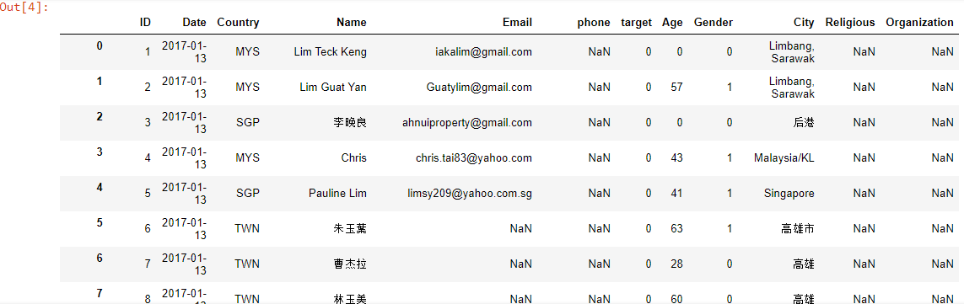  
     
   A final issue I have found with the dataset is that it is messy due to people’s carelessness when filling out the online forms. Since the primary focus of the movement had been to maximize the quantity of pledgers, many fields were left optional, In previous years, when the movement was still in its infancy, pledgers would input their information in plain text fields. As a result, a large majority of people would: write their information in the wrong text fields (ie: putting their name where their emails should be), misspell their information, or use an entirely different language altogether, since we are catering to an international audience. This resulted in a long time spent on cleaning data and throwing out invalid entries. This year, fields such as Country and Gender are dropdown menus and multiple choice selections to eliminate invalid entries.
5. Analysis
   1. Country  
      The first and most obvious point of analysis would be to analyze the country of origin of the pledgers. Since it is not a continuous measurement of quantity, I found the best graph to represent this data was the bar graph. Below is the first attempt at plotting the ‘Country’ bar graph.  
      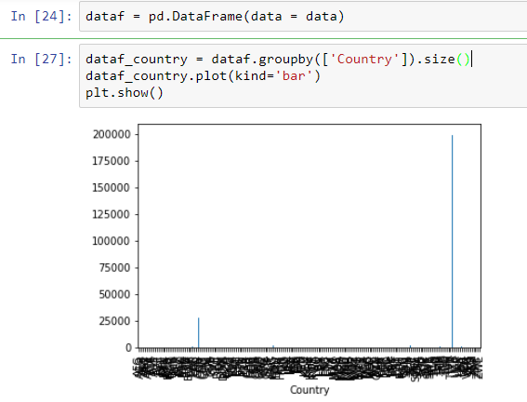  
      As one can see, there are hundreds of entries under ‘Country’, as this movement was promoted in the UN Climate Change conference, which has representatives from over 190 countries around the world. A more feasible representation of the data was to simply graph the leading five countries in a clear and concise manner.  
      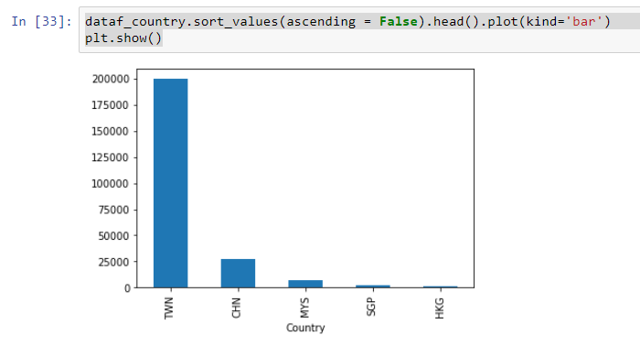  
      As one can see, those with the origin country of Taiwan significantly dominates all other countries, with roughly 10 times more pledgers than the second most country, China. Malaysia, Singapore, and Hong Kong trailing behind.   
      This bar graph is a measure of the reach and influence of our organization. Even though this movement originated from the United States (I was involved in the creation of it), the United States is nowhere to be seen on this graph. Since our organization originated from Taiwan, and with our religious founder, the highly influential Dharma Master Cheng Yen promoting the movement in our own television channel, it is not surprising to see how much more influence we have in Taiwan than anywhere else in the world.
   2. Age  
      Another data point that I felt would be interesting to measure is age. I thought it would be interesting to see how old our constituents are. I have always noticed our volunteers, employees, and participating members have always been of the older generation, particularly older women. Upon plotting the data, I noticed a few key insights. For one, a significant majority of the pledgers are age 0. No, these are not toddlers signing up for the cause. The most obvious explanation is that the age is not a required field, so people generally choose to omit this information. I have noticed when volunteers are out promoting this event, they tell people to simply fill in the required fields: the name and country. It seems that volunteers and members, for the most part, are simply rushing to get signatures into the system.  
        
      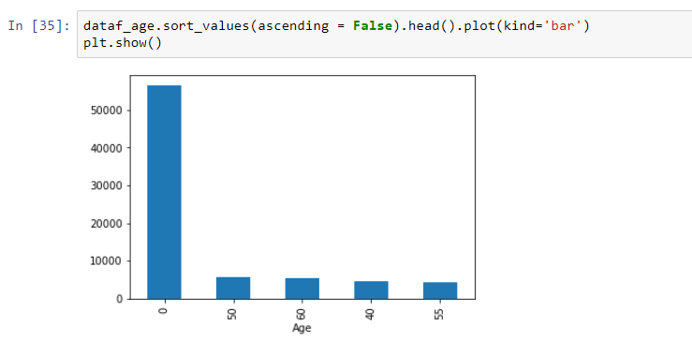  
      Another interesting fact that I have noticed about the resulting bar graph is that people have a slight tendency to round their age to the nearest 5, as the rest of the most frequent ages were 50, 60, 40, and 55 respectively. Whether this was mere coincidence or the result of more carelessness, it was an interesting observation nonetheless. To see if there were more that fit the pattern, I decided to plot the top 10 most frequent ages instead of merely 5, as well as removing the erroneous “0 years of age”. Below was the result.  
      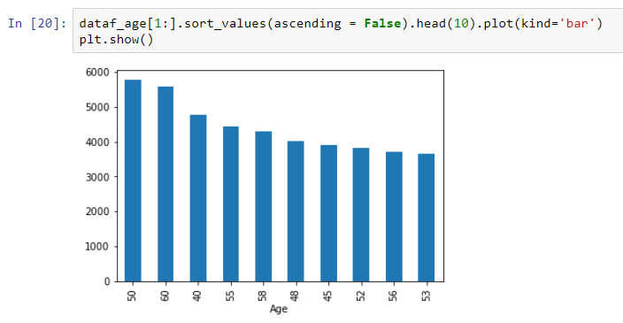  
      It seems, though the trend was broken, it can still be said that the older ages rounded to the nearest 10 (50, 60, and 40 respectively) are still the most prevalent in the dataset.  
      Lastly, my suspicions that this organization is comprised primarily of old people are confirmed. The top 10 ages of the pledgers are above the age of 40, with most being in their 50s. Since we are a Buddhist charity organization, it makes sense that those in retirement age would be more likely to participate in the volunteering activities we offer. Also, it has been observed that religious organizations such as Tzu Chi Foundation would be predominantly followed by the older generation.
   3. Date  
      I felt it was necessary to explore was the date in which people signed up to pledge to this movement in order to determine the most effective activities we have to promote this movement. Again, I felt the bar graph was most suitable for this analysis.  
      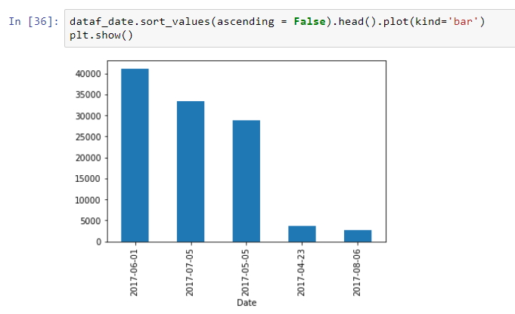  
      Very interestingly enough, June 1, July 5, and May 5 inspired more people to pledge than any other dates by a large margin. I would need to check with our headquarters to see which activities were held on these days.
   4. Gender  
      I was also curious to see the gender breakdown of the pledgers. In my observations, this organization is predominantly followed by middle aged to retired Taiwanese women; men are often in the minority since the religious leader is a female Dharma Master, meaning only women could be her disciples. Of course, as with all gender breakdown graphs, the Pie chart is most appropriate.  
        
      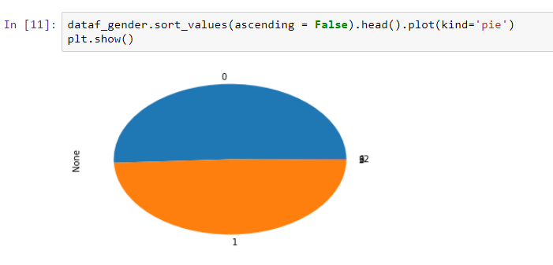  
      To my surprise, the females (‘0’) only slightly outnumber males (‘1’).
6. Next steps  
   These first analyses have given me more insight into my organization, how our volunteers operate when promoting Ethical Eating Day, and what are the biggest factors in ensuring reach. However, we are nowhere near our goal of empirically analyzing and determining the amount of CO2e reduced through a reduced-meat diet. For this, I would need an additional detailed dataset from a reputable source (ie: FAO) on the methane emissions from factory farming and livestock by country. If I can link the two datasets, I hope to convey the narrative through 3 different assumptions: 1) pledgers continue their meat-eating habits from this day forward, 2) pledgers reduce their meat intake by 50%, and 3) pledgers eliminate meat from their diet immediately. Additionally, I will request a more updated dataset on January 11 so we could share the updated analysis with the pledgers.